Fighting to the last man at Sidi Nsir

26th February 1943: British gunners from the 155th Battery alongside the Hampshire Regiment make a famous stand against a fresh German assault
FEB 26

SAVE |  | ▷ LISTEN

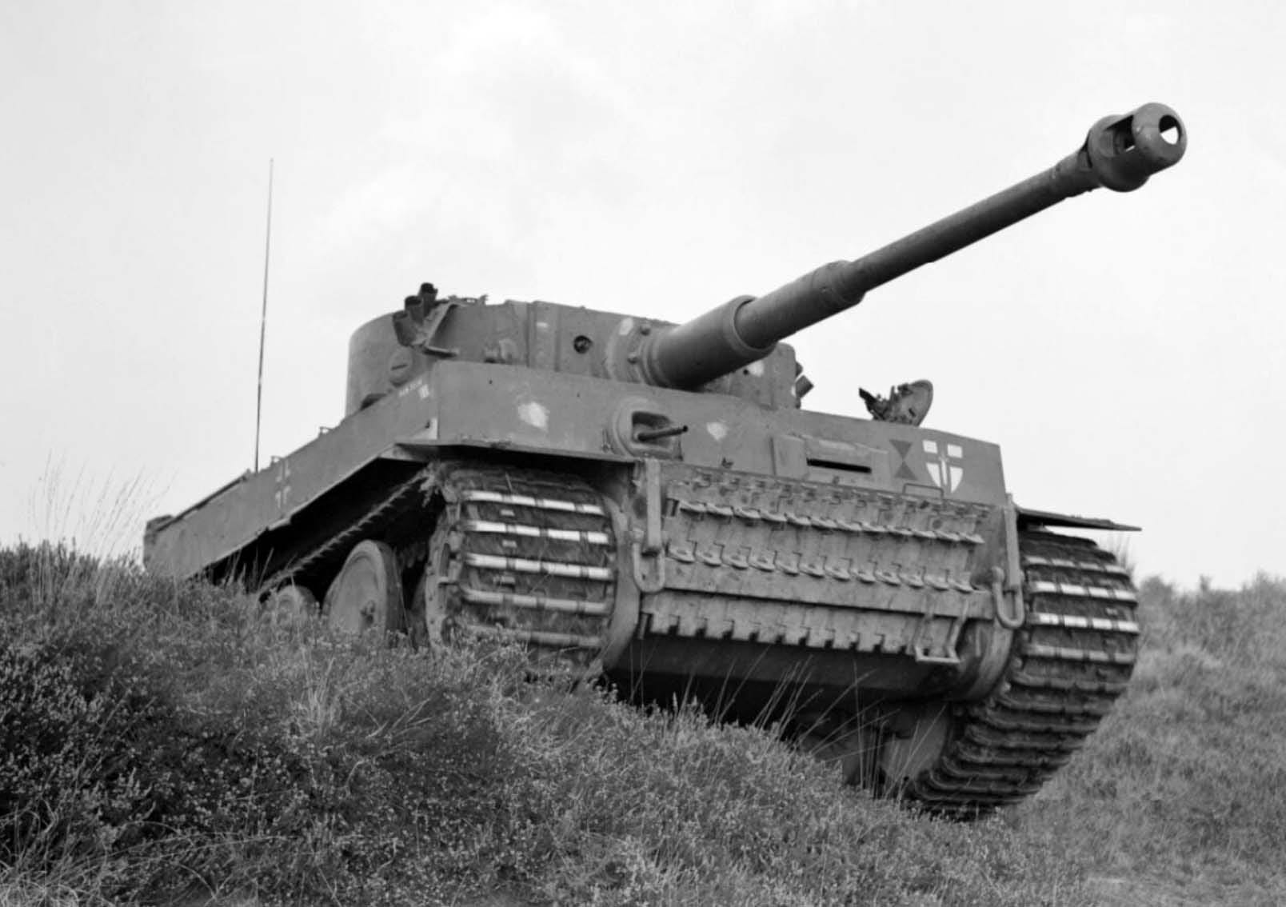
The Tiger 1 had recently arrived on the battlefield in Tunisia and the Allies were still working out the best tactics to deal with it. A Panzer VI captured by the British Army later in the campaign
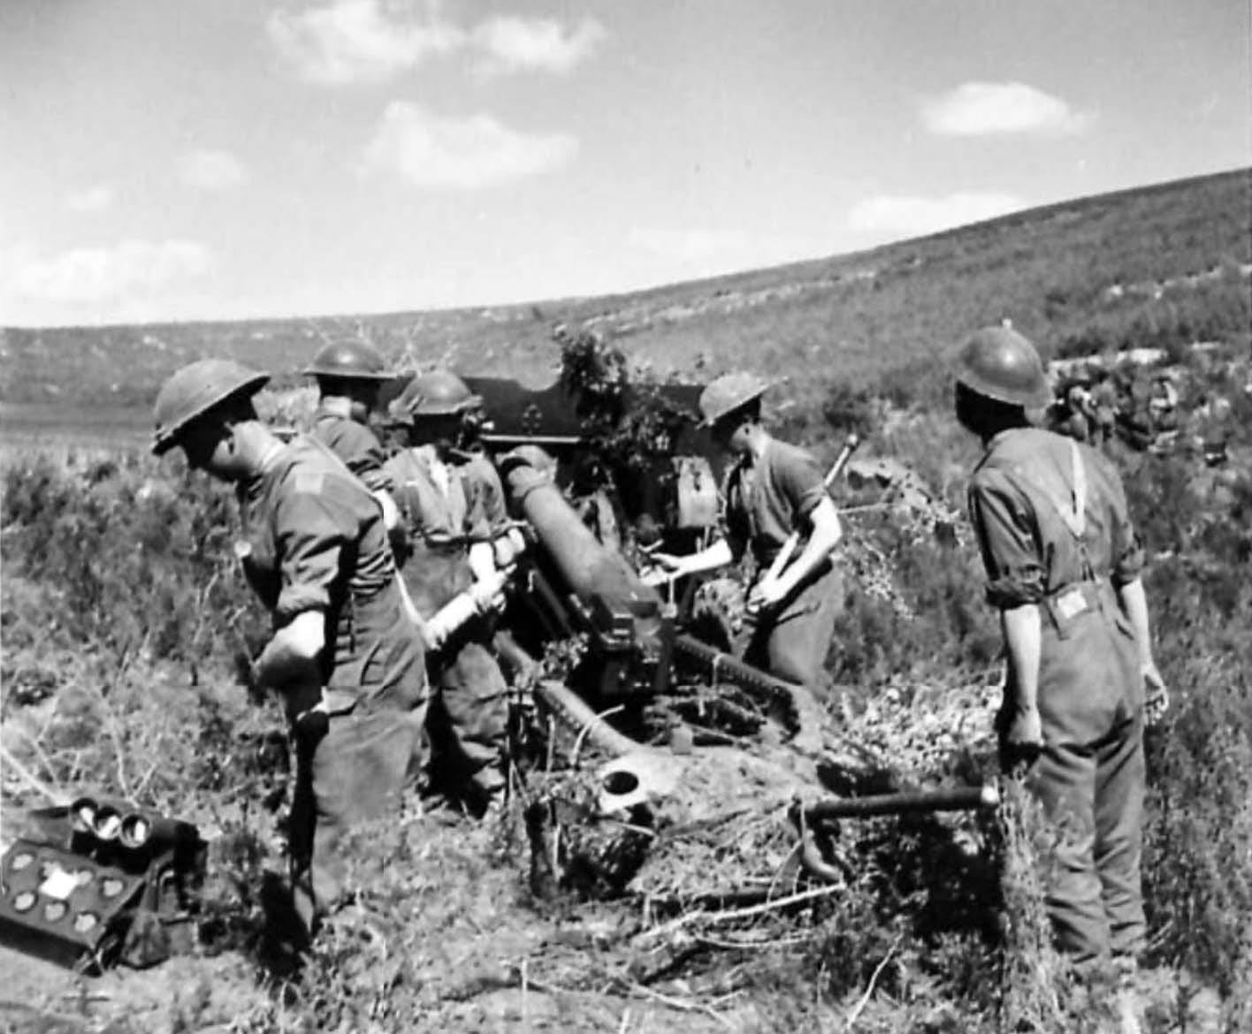
A British ‘25 pounder’ field gun in action in Tunisia.
In aftermath of the battles at the Kasserine Pass, General von Arnim launched Operation OCHSENKOPF (Ox Head) - a three-pronged assault on British lines in Tunisia. One of these attacks was made by ‘Kampfgruppe Lang’ - a battle group of panzers, including a number of Tigers. Supported by the Luftwaffe, they sought to break through to ‘Hunt’s Gap’, the only route through the mountainous terrain accessible to tanks.
Standing in their way was the remote outpost of Sidi Nsir railway station, twelve miles in front of Hunts Gap. Here the 155th Battery of the 172nd Field Regiment RA, alongside the infantry of the 5th Battalion Hampshire Regiment, was to make an epic stand.
F Troop engaged them, No 1 gun over open sights. Three tanks were hit and the road was blocked very conveniently just where it passed through a protective minefield. No 1 gun remained in action in spite of mortar and machine-gun fire.
On the 26th February 1943, the Germans attacked this position intending to break through the British lines - in what could have been a major reverse for the Allies in Tunisia.
The nine officers and one hundred and twenty-one men of the 155th battery were to bear the brunt of the action, only nine of them would not be killed, wounded or captured. Brigadier Graham¹, commanding 172nd Field Regiment RA, left this account:
That night an abnormal number of green and white Very lights were seen, and by dawn the mountains and valleys all around were alive with the movement of troops, guns, tanks and infantry columns.
Soon after 6 a.m. on February 26th F Troop came under fire from mortars behind Chechak Ridge and replied with artillery fire. From this moment until dark, F Troop and to a lesser degree E Troop and the command posts, cooks’ shelters, etc, were under increasingly heavy mortar fire. At 7 a.m. enemy tanks attempted a direct assault down the main road from Mateur.
F Troop engaged them, No 1 gun over open sights. Three tanks were hit and the road was blocked very conveniently just where it passed through a protective minefield. No 1 gun remained in action in spite of mortar and machine-gun fire. Captain Lawrence had decided to stick to his observation post on the Chechak ridge. Later his bravery in an attempt to escape from prison cost him his life.
At 9.40 a.m. Point 609 was heavily attacked by infantry. Communication was broken, WT sets smashed by enemy mortars and all lines cut. Lieutenant McGee was wounded and taken prisoner. (He subsequently escaped, reached the British lines in Italy and had the desperate ill-fortune to be drowned on his way back home.) From this moment on, the battery had but secondary ‘eyes’ over-looking the Mateur road, which must have been packed with enemy tanks and vehicles.
But the tanks in hull-down positions had a great advantage over our guns and engaged them one by one, setting ammunition dumps, killing or wounding the detachments and eventually smashing the guns themselves.
At 10.15 the CO visited Major Rawford on the gun position. F Troop was then under observation at a range of about 800 yards, and the track leading down to the command post was under very heavy and accurate mortar fire, rounds falling every three seconds or so. On all eight guns the CO found the detachments full of cheerful and determined courage.
Lieutenant Taylor and Sergeant Henderson (both of F Troop) in particular stood out by reason of their undaunted offensive spirit and the inspiring example they set. Sergeant Henderson was the No 1 of No 1 gun, specially placed on the top of the slope to deal with enemy tanks trying to use the Mateur-Sidi Nsir road. Taylor was the only officer on F Troop position, and he fought there until he was killed.
At this time Messerschmidts attacked from a height of about 200 feet and racked the gun positions with machine-gun fire and cannon fire. A number of vehicles were burning along the road Sidi Nsir- Hunt’s Gap, some of them filled with ammunition and ammonal; but the risks were ignored by officers and men alike as they cheerfully salvaged and carried the shells throughout the action. The wounded acted stoically; none grumbled or complained.
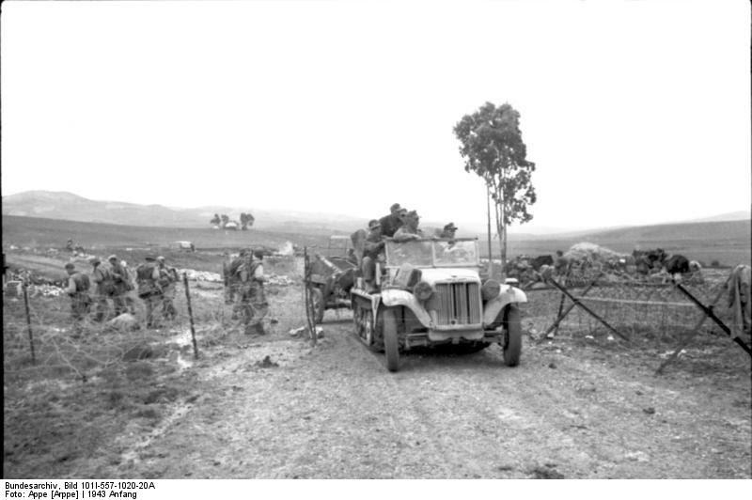
A German halftrack tows an antitank gun through a gap in the British wire. The halftrack has just passed through the intersection and is moving toward the Sidi Nsir station. The road to the left goes to Tebourba while the road to Beja is barely visible in the background behind the halftrack
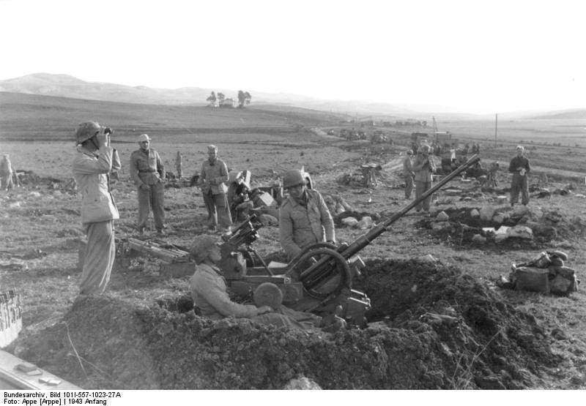
German light flak setup in the road intersection. On the left, behind the 20-mm flak, is the road to Tebourba. The road and railroad to Beja is visible in the background with traffic moving in both directions
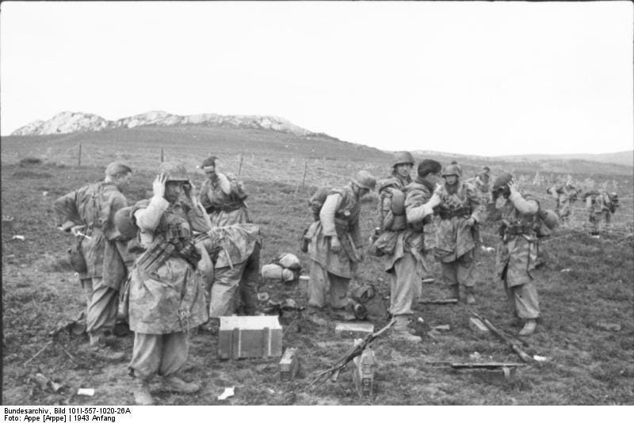
German infantry forming up in the same location.
The enemy tanks (reported to number 30) and infantry had wormed their way into positions around the flanks of the guns. All this time the battery was completely occupied in engaging enemy infantry, machine guns and mortars, which were closing in on the Hampshire company positions.
The battery fired as many as 1,800 rounds per gun during the fierce, relentless day. Bren guns claimed four Messerschmidts – a triumphant reward for days of patient shooting on the balloon range at Lydd before leaving England.
The gallantry of the infantry, isolated on the tops of stony djebels, was superb. Both artillery and infantry were equally determined not to let their opposite numbers down.
At 3 p.m. a column of the enemy infantry penetrated between Hampshire Farm, two miles or so to the west of Sidi Nsir – Beja road, and the gun positions, and no more ammunition could pass. Twenty minutes later, under covering fire from some 13 tanks in hull-down positions (firing MGs and guns), more tanks attempted to advance down the main road. A Panzer Mk VI was leading. This was hit three times by Sergeant Henderson’s gun.
A smaller Panzer Mk VI tried to pass, but this in turn was knocked out by No 1 gun. Yet a third tank was set on fire by the same gun.
The enemy held back, shelling and machine-gunning the positions, particularly F Troop, which was more easily spotted. Both troops were now in action against enemy tanks over open sights.
But the tanks in hull-down positions had a great advantage over our guns and engaged them one by one, setting ammunition dumps, killing or wounding the detachments and eventually smashing the guns themselves.
At four o’clock another attack was put in from the Mateur road against F Troop’s southern flank. Sergeant Henderson smashed up the leading tank, but immediately afterwards he and his entire detachment were knocked out by a direct hit. (Sergeant Henderson recovered later in an enemy hospital.) The tanks then came on over the ridge in front of F Troop, who still had three guns in action and engaged the enemy at ranges of from 50 to 10 yards with Lieutenant Taylor, the fitter, cooks and all the survivors running from gun to gun and servicing each in turn.
At this stage the slope of the ground, which is steep and convex, gave the gunners some much needed help, for the attacking tanks were handicapped by their limited ability to depress their guns. F Troop fired for over an hour more before they were finally silenced. Then the tanks moved down the road past F Troop and surrounded E Troop.
…
At 5.51 p.m. the last message came back over the wireless, ‘Tanks are on us’, followed a few seconds later by the single letter ‘V’ tapped out in Morse.
The action had not been in vain. The Germans still had to find a way up the “winding, narrow single-track road” to Hunts Gap. The other two batteries of 172nd Field Regiment RA were fully prepared when the attack was resumed on the 27th February:
[L]ong before the enemy reached Hunt’s Gap he was pounded continuously by a heavily reinforced artillery which had made full use of the 24 hours’ respite to establish extra ‘eyes’ in the mountains, as well as large dumps of ammunition.
The road by which the enemy advanced stretched mercilessly for miles and, as luck would have it, it rained and rained and rained. It was if the enemy had walked deliberately into a carefully baited trap. His heavy tanks floundered in the mud.
His heavy tanks floundered in the mud. They became trapped on a narrow road from which they could not turn back. Their drivers were panicked by concentrations of artillery fire from a daily increasing weight of field guns…
They became trapped on a narrow road from which they could not turn back. Their drivers were panicked by concentrations of artillery fire from a daily increasing weight of field guns, until eventually they themselves completely blocked their only route of advance.
Then, for ten days, field and medium guns hurled thousands of shells upon them, smashing their tanks and vehicles on the road and mowing down their infantry when they tried to get round over the barren hills. The gunners of 153rd and 154th Batteries took a remorseless revenge for their comrades of 155th who had died at Sidi Nsir
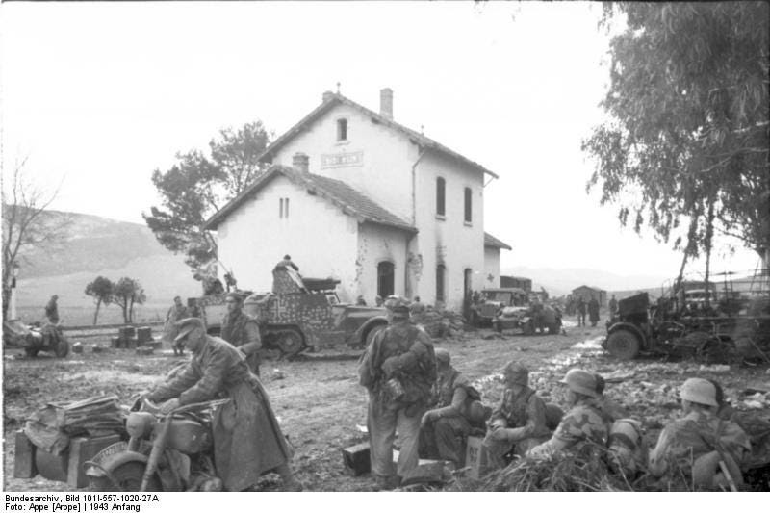
After the battle. A view of the southwest end of Sidi Nsir train station along with motorcycles, halftrack, Kubelwagen, and a captured U.S. halftack in German service
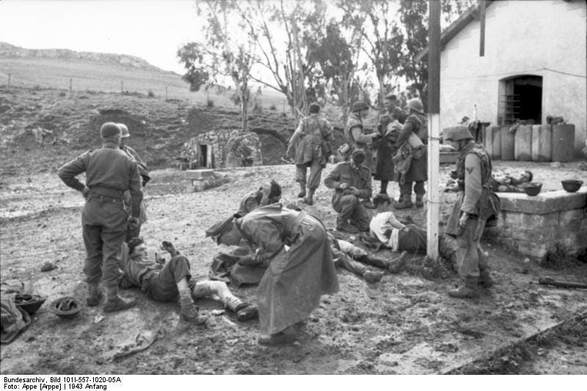
British wounded and German soldiers at the northeast end of the station
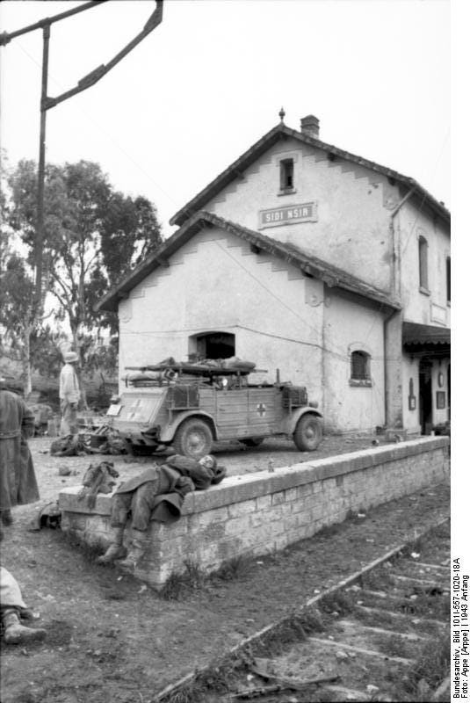
A Kubelwagen ambulance has arrived and one stretcher has been loaded. The name of the station, Sidi Nsir, is visible on the station sign
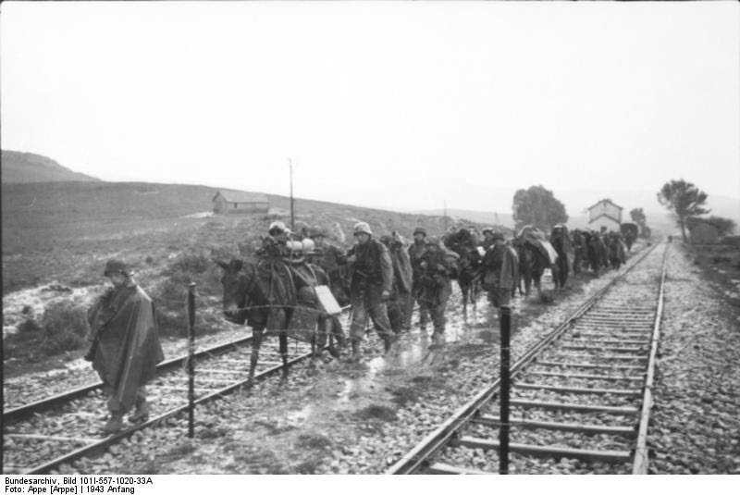
A column of German troops and British prisoners leaves Sidi Nsir heading along the railroad tracks in the direction of Mateur. The Sidi Nsir station is visible in the background.
1
Brigadier Graham’s account is in the anthology The War on Land, 1935-45.

